SSGT Frank T Joswiak
Brenham, Texas
Born 14 September 1906 – Died 30 May 1980
63rd Bomb Squadron, Gunner
Enlisted 10 April 1942 – Released from Service 3 October 1945
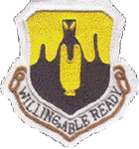
Provided by: Mitchell Draehn, Grandnephew

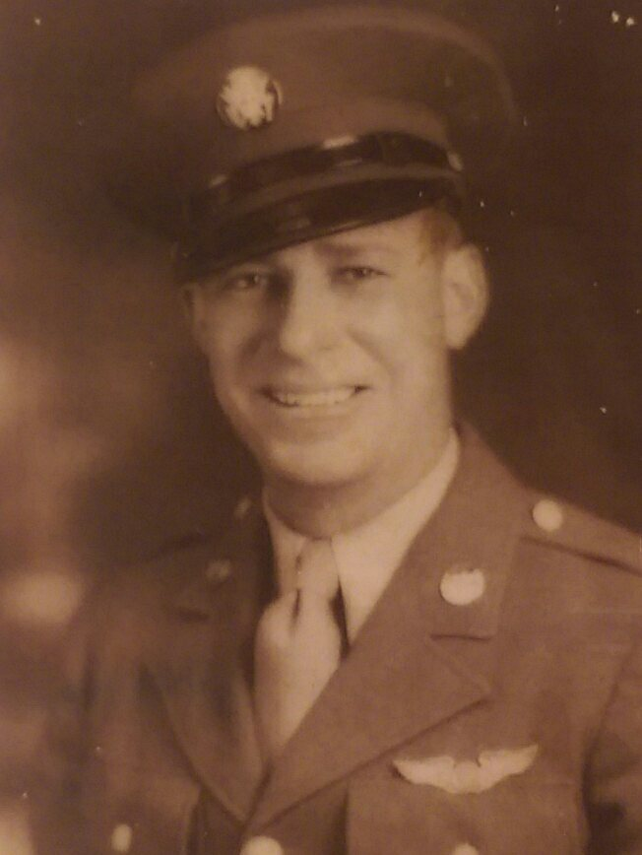

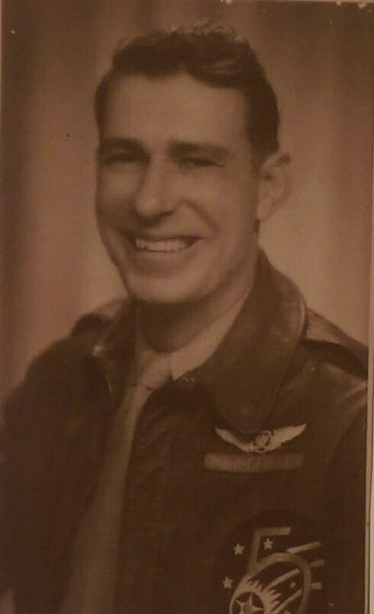

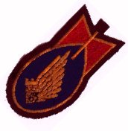

‘Old Gunner’
Enlisted at age 35½ – Released from Service at age 39

SSGT Frank T Joswiak
Brenham, Texas
Born 14 September 1906 – Died 30 May 1980
63rd Bomb Squadron, Gunner
Enlisted 10 April 1942 – Released from Service 3 October 1945
Provided by: Mitchell Draehn, Grandnephew
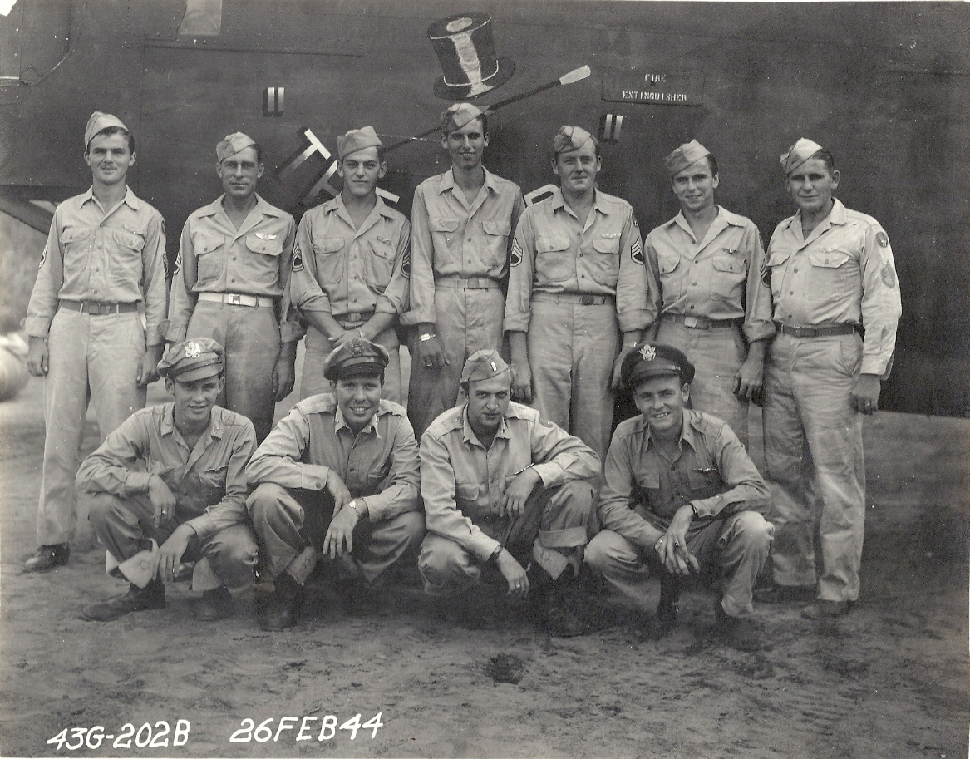
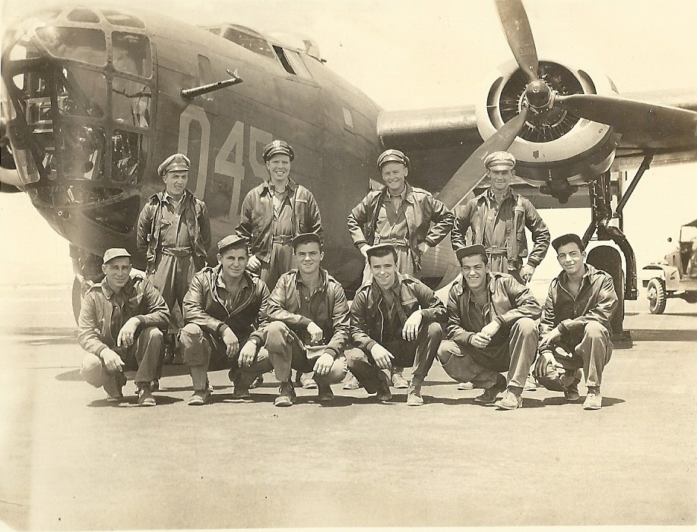
Crew photo, SSGT Frank T Joswiak kneeling at far left of photo
Crew photo, SSGT Frank T Joswiak standing, second from left
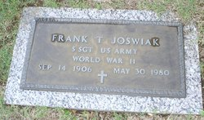
Buried at Cavalry Hill Cemetery Dallas, Texas

