***TSGT Leo H. Thaler***

***Rockaway, New York***

***Born 8 November 1923 – Died 5 April 2012***

***403rd Bomb Squadron, Flight Engineer / Gunner***

***Assigned January 1945 – November 1945***

***Provided by: Dr. David J Thaler, Son***

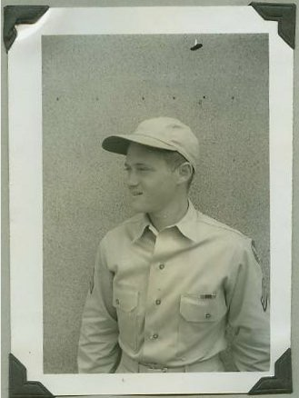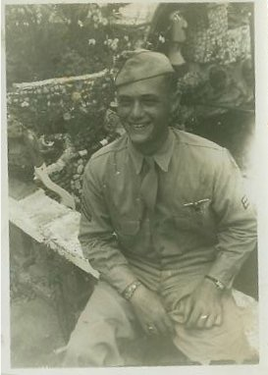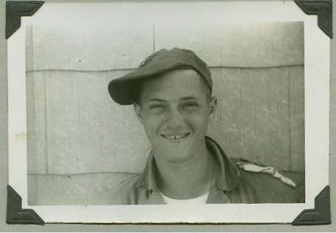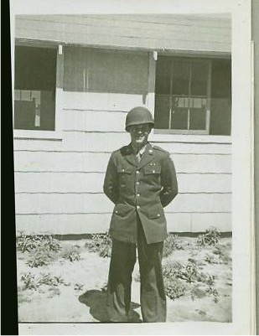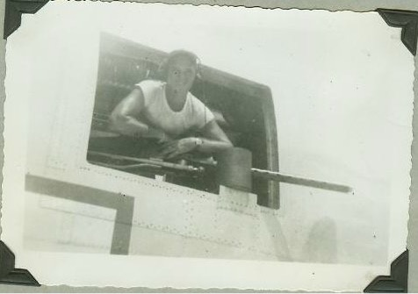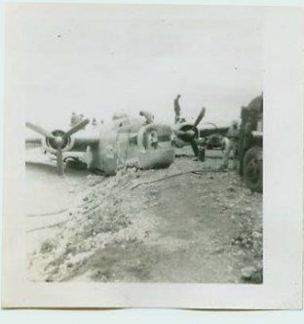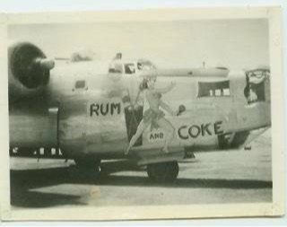

***Friday, 13 April 1945 – Island of Ie Shima***

***Crash of B-24 44-49827, ‘Rum and Coke’***

***TSGT Thaler’s Pictures and Mission Log Write-up***

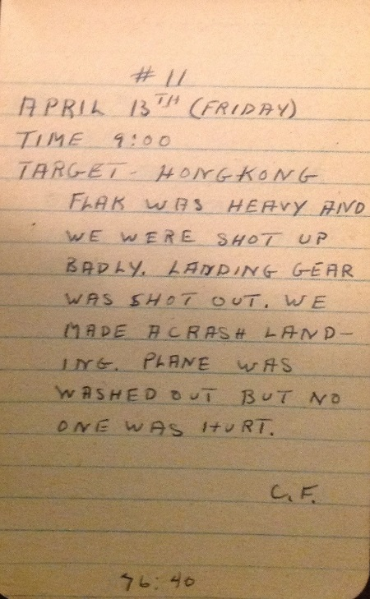

***Leo H Thaler***

***Laid to Rest***

***Maimonides Cemetery - Elmont, New York Age 88 years***

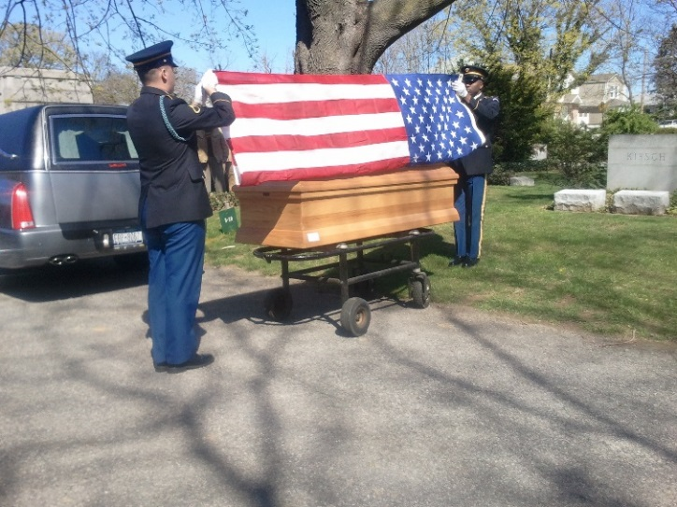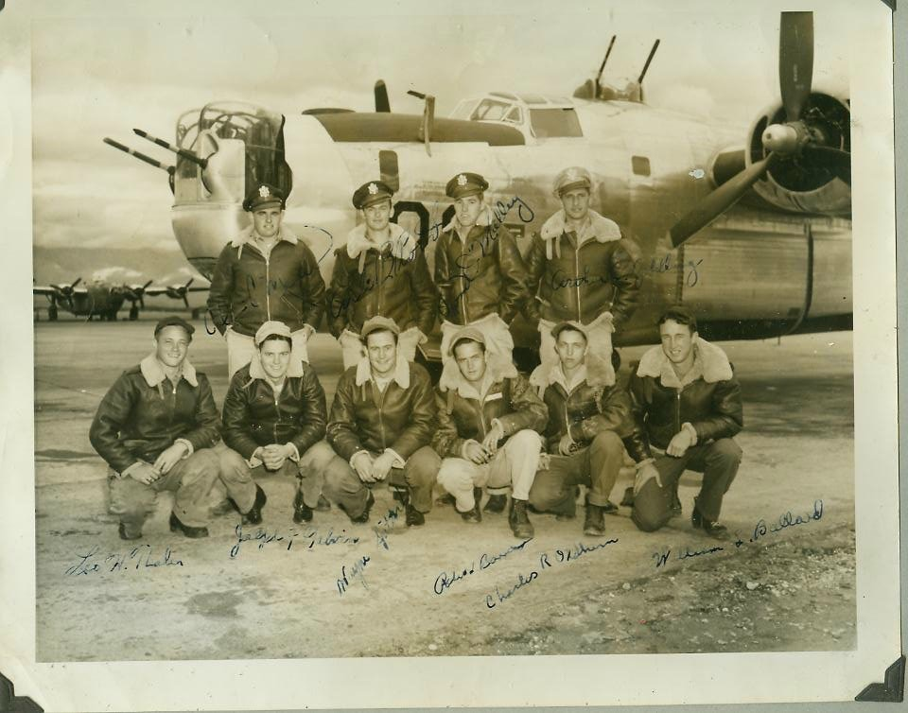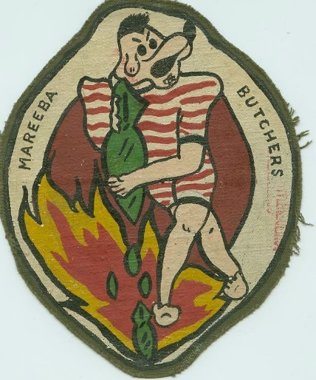

***Crew photo, TSGT Leo H Thaler kneeling at far left of photo***

***TSGT Leo H. Thaler***

***Rockaway, New York***

***Born 8 November 1923 – Died 5 April 2012***

***403rd Bomb Squadron, Flight Engineer / Gunner***

***Assigned January 1945 – November 1945***

***Provided by: Dr. David J Thaler, Son***